WHAT CAUSES VARIATION IN PLANTS

Introduction
This exercise follows the genuine, scientific investigation that would have required many weeks for completion. If you are reading this, then you likely have plants that have died, which would cause an end to the experiment.
But fear not, I have attached photos, for your viewing pleasure, of all the different stages of the plant’s development from real student experiments which will allow you to complete the lab on your own (remember, it is still on you to understand the data, the methodology used and do the final analysis for grading).
We have been using fast growing mustard (Brassica) plants as our experimental organism. The title of this unit is the general question that we are trying to answer, but we will narrow it down in the process of designing and carrying out the experiments.

Procedures
The experiment should have begun by making some initial observations about the “A” and “B” type plants, but if you didn’t yet, or your plants died before you could, you can make then now from the photos in figure
1. Carefully compare the plants in the quads and identify any consistent differences that you see between them. Record your results on the next page.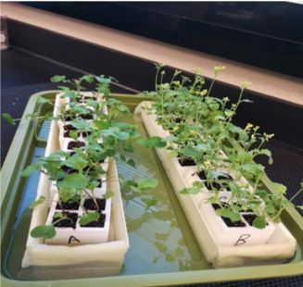
Figure 1.
1. What differences do you observe between A and B plants? Here’s a hint. Look at the stems!
Plant A has purple stems as opposed to plant B which a green Stem.
Plant A has leaves that have enough chlorophyll and his is seen from their green appearance as opposed plant B with little amounts of chlorophyll and thus the leaves re turning yellow.

2. What question(s) are suggested by your observations? One question might be, “what makes one stem color different from the other?”
What makes plant A’s stems purple while the plant B’s stems are green?
What makes the leaves of plant A appear much larger than the leaves of plant B?

The question we are going to have you ask is, if you cross plant A with plant B, what will the offspring look like? More like A? More Like B? A Mix of the two? Regardless of what you think the answer may be, it is your hypothesis…so write it below in #3.

3. What potential answers (hypotheses) can you think of for the question that you have chosen? Remember a hypothesis is an EDUCATE
Crossing plant A, with plant B, would lead to offspring with a mix of the traits from both plants.

4. Now that we have a hypothesis, we need to set up an experiment to test the hypothesis from the previous question. We will take true breeding “A” plants and cross pollenate them to true breeding “B” plants and when they make baby “seeds” we will call “C” plants, we will plant them and see what happens (you probably already planted these, by the way, but they may have died).

Week 2- let’ s check our “C” plant babies:
- Get the plants that you planted last week and make some observations (or since your plants probably died, you can just look at the photo below):
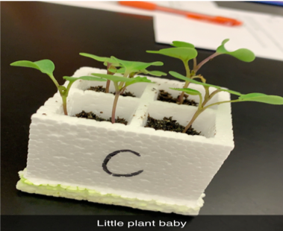
Figure 2.

- Record your observations here.
Plant C has inherited traits of both plant A and plant B. The stem appears more colored that that of plant B but less colored than plant A.

- Based on your observations, which hypothesis from last week is supported?

I support the hypothesis generated that plant C would be a mix of both plant A and plant B.

- What new questions can be asked based on the data you have gathered? I’m going to help you out here. Obviously something happened to the “B” trait. Is it gone? Remember your Mother or Grandmother telling you traits skip generations (like red hair)? Well maybe that’s what happened, so we are going to cross the babies with each other and find out!
Write what you think happened below:

Plant B did not lose its traits completely but it was dominated by the traits of plant A and thus plant C is healthier than plant B. The stem color is not much green nor is it more purple.

- We need to design a new experiment to test this new question? Like we answered it #4 above we are going to cross “C” with “C” and see what the babies look like. If it goes the same as Mendel, then we should have a 3:1 ratio or “A” traits to “B” traits.

After the Mendel’s crossing has been done on “C” with “C”, the offspring will have three with dominant trait, that is green stems and one offspring with yellow weak stem.

WEEK 3-Bee time (cross pollination of C and C plants):

Your plants are growing well (we are pretending now), and now it is time to pollinate them! You will act like a bee and pollinate your plants. We brushed up some of the pollen from the male flower and transferred it to the pistil on a female flower.

Below a picture of your actual plants:

[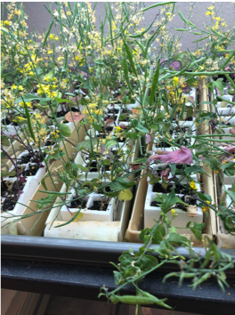
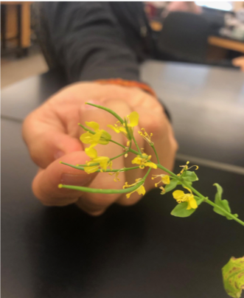

Week 4- stop the water:

Your plants are thriving, they are growing well, and they started to develop some pods. We now need to stop watering them, so they will dry up.

Left is a picture of your plants at this stage, before we stopped watering them:

Week 5- Harvesting and Germinating Brassica Seeds

Your plants are all dry now, so we are ready to harvest the seeds from C crossed with C!!
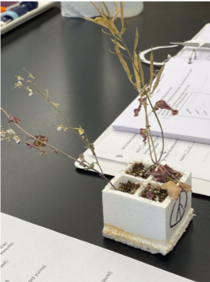

Directions for Harvesting and Germinating Brassica Seeds

- You would harvest all the dried seed pods from the mature plants. They should be brown in color and crumble easily.

- You would have crumbled the seed pods over a piece of paper or onto a tray.

- You would have separated the seeds from the dried pod husks.

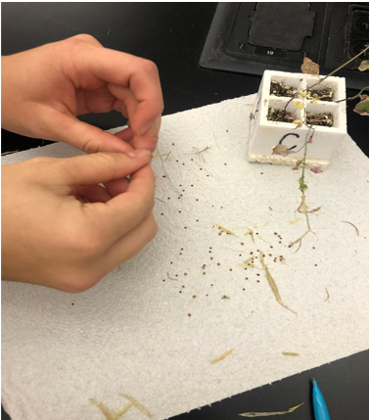

. . .
. . .
. .

- You would have cut a piece of filter paper to fit the larger diameter side of a Petri dish (side less deep).

. . .. . . . . . . . . . . . . .

Seeds stick by adhesion to the wet filter paper. The bottom 1/3 is left empty of seeds.

- You would then wet the filter paper and add the seeds (about 30 per dish) leaving the bottom 1/3 empty of seeds.

6. You would have covered the Petri dish with the other side and taped it together, written your group’s name on it, place it upright, slanting slightly in water using the same trays as were used to grow your original A and B plants.

7. Your seeds would be facing the light and would germinate directly on the paper for one week.

Analysis:
It is time to count your seedlings that you would have germinated on the filter paper last week:
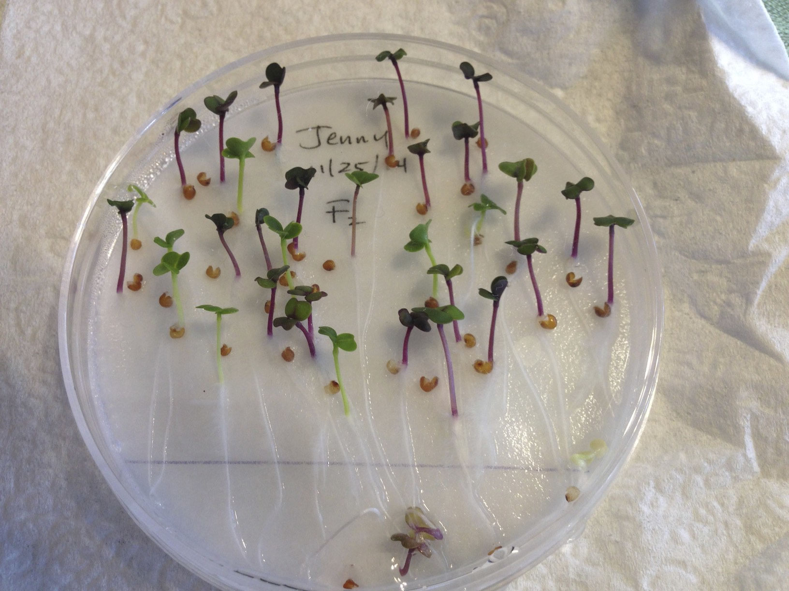

They represent the offspring from crossing “C” plants (CxC=?). Record the stem color as “purple or green”. If there is any purple on them, then they count as purple!

Stem Color | # of plants
Purple | 21
Green | 9

Review your earlier Observations (PLANT A AND B) as you answer question #1 below:
- Re-read your handout from when we first started to grow the Brassica plants
- What color were the parent plant stems, the A and B plants?

Plant A stems were Purple. Plant B stems were Green.

b. The parent plants were crossed by the Biological Supply Company (AxBC), and we planted the offspring seeds, “C”. What color were the “C” plants? Use the class data collected weeks ago, NOT the data collected today.

Stem color of “C” plants | #
Purple | A
Green | BB B

- Watch this video on Mendel genetics
https://www.khanacademy.org/test-prep/mcat/biomolecules/mendelian-genetics/v/an-introduction-to-mendelian-genetics

- Do a Punnett square of the Parent plants: “A” crossed to “B”

- Complete dominance hypothesis: PP x pp
P=purple allele p=green allele

Punnett square of Parent Plants
Predicted Phenotype of C plants (F1):
Three purple offspring and one green offspring.

Predicted Genotype of C plants (F1):
Pp, Pp, Pp, pp

P P
Pp | Pp
Pp | Pp

3. Punnett square of the Offspring C (F1) plants. “C” crossed to “C” = F2
A cross of the “C” plants represents a cross of the F1 plants producing F2 offspring.
Use the same hypothesis that you chose for the previous Punnett square. Either:

- Complete dominance hypothesis. Pp x Pp.

Punnett square of F1 plants

P p
Predicted Phenotype of F2 plants (F2):

Three purple offspring and one green offspring

Predicted Genotype of F2 plants (F):
p PP, Pp, Pp, pp

PP | Pp
Pp | pp

4. Now go back and look at the data that you collected from the “seed plate”. This represents the actual F2 plants. Does your “Predicted Phenotype of F2 plants” from the Punnett square above match your actual data ? (Yes/No) Circle one!
We will find out!
5. Because we are doing this lab virtually, we cannot record all the data from the entire classroom. But hypothetically, to test our hypothesis and compare the F2 predicted phenotype with our actual counts, if we could, would it be more accurate to use only your group counts or the entire class results?
It would be more accurate if we counted the results from all eh groups in the entire class.

Think about surveying this biology lab class about how many people they “texted” yesterday, and how many “texts” they sent out. Do you think the survey results are representative of all community college students across the United States? (Yes/No). Explain why you answered the way you did.
The survey done might cover a greater part of the traits portrayed in a certain place but it might not be a representation of all the individual traits within the population.
In our everyday life, we often give too much importance to data collected from small sample sizes. Small sample sizes are often biased, and not representative of the total population. Although this might seem obvious, Daniel Kahneman won a Noble prize in economics in 2002 partly for this observation of human behavior.

6. Next step, fill in the table below with the F2 plant data. Choose only the table for the hypothesis you are testing.
a. Complete Dominance Hypothesis
Phenotypes of F2 plants | Purple Green
Number of plant stems | 21 9
Total plants | 30 30

b. Incomplete Dominance Hypothesis
Phenotypes of F2 plants | Purple | Green
Number of plant stems | 21 | 9
Total plants | 30 | 30

- We will do a statistical test called the Chi-square test to see if your data supports your hypothesis.
Chi-square is a statistical test used to compare observed data with data we would expect to obtain according to a specific hypothesis. The procedure tests the goodness of fit between observed data and our expectation.
Think of it this way. Let’s say you are flipping a coin with a friend. $1000 a toss. You will do 10 tosses. Heads they win, tails you win. How much extra money would you expect to get from this battle? None? You would be right because it should come up half heads and half tails, every time you won a grand you would have to give it right back. No harm no foul…but what if it came up heads every time? Would you suspect your friend of cheating? When would you say they were a cheat? 6 times heads? 7 times heads? 8? Scientists must figure this out all the time to tell when a drug should be approved or not. When is it helping or just based on dumb luck? Casinos do this too. They did it to Ben Affleck, and they used a chi-square analysis as evidence. https://www.hollywoodreporter.com/news/ben-affleck-banned-life-hard-700959

Watch this video to better understand this test: https://www.youtube.com/watch?v=WXPBoFDqNVk
Now that you know everything about the Chi-square test, let’s use it! Choose only the table for the hypothesis you are testing and write down the numbers.
a. Complete dominance
 | Purple | Green
Observed (o) | 21 | 9
Expected (e) | 16 | 14
Deviation (o - e) | (21-16)= 5 | (9-14)=-5
Deviation² (d²) | 25 | 25
d²/e  (Deviation² /expected) | 25/16= 1.5625 | 25/14= 1.7857
X² = Σd²/e  (sum of all your Deviation² /expected results) | 1.5625 + 1.7857 =3.3482

Now that you have your value for the X² look at the Chi-square distribution table below:
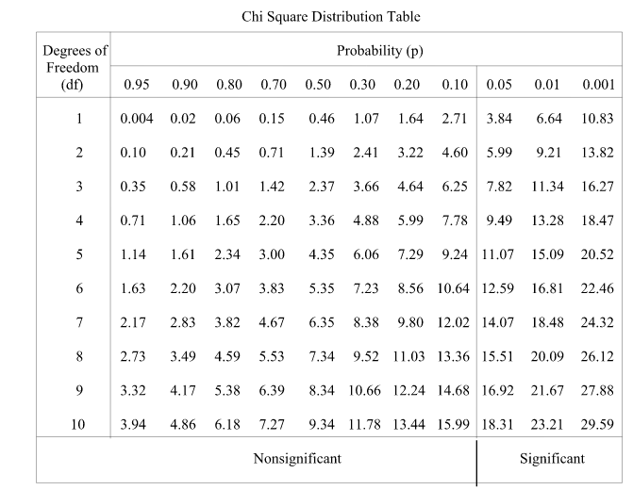
Use the row of df=1 if you are testing complete dominance. Use the row of df=2 if you are testing incomplete dominance. Find the number closest to your Chi-square. Then follow the column up to the top to find your probability (P-value). List it here.

P= 3.22

9. If P is > 0.05, then your hypothesis is accepted. Is your hypothesis accepted?
Yes, my hypothesis is accepted.

10. Which hypothesis was accepted by the class, complete dominance or incomplete dominance?
There is a significance difference between the observed and expected data.
11. Compare this experiment to Mendel's experiment with purple and white flowered peas. (Fig. 14.5 in Campbell text)
a. What was different?

The experiment can be used to determine probability from a large sample population while the purple and white flower peas experiment applies only for specified number of organisms.

b. What was similar?

Both experiments increase our understanding on the genetic variations in plants.

